**University of Westminster**

**Software Development I**

**4COSC006C**

**TEST PLAN**

**Part 1**

**Name** – A.W.Pinidu Rasanjana

**UOW Number** – w2053073

**IIT Number** - 20231611

1. Table of Contents

**2** **list of Tables** 2

**3. list of Figure 2**

**4. Test case Table 4**

**5. Test cases screen shots 5**

# 2 list of Tables

Table 1 : Test Cases 4

# 3. list of Figure

Figure 1 : Progress 5

Figure 2:Progress (module trailer) 5

Figure 3:Module retriever 6

Figure 4:Exclude 7

Figure 5:Validation 5.1 7

Figure 6:Validation 5.2 7

Figure 7:Validation 5.3 7

Figure 8: Histogram 7.1 8

Figure 9: Histogram 7.2 8

Figure 10: Part 2………………………………………………………………………………………...8

Figure 11: Part 3.......................................................................................................................................8

|  |
| --- |
| **4COSC001W: Software Development I – TEST PLAN**  **Student Name/ID: Pinidu Rasanjana**  **20231611**  **w2053073**  **Date:11/12/2023** |

# 

# 4. Test case Table

Table 1 : Test Cases

|  |  |  |  |  |  |
| --- | --- | --- | --- | --- | --- |
|  | Student Name:  Student ID: | | | | |
|  | TEST PLAN for Part 1  **Submit completed test plan with your code solution** | | | | |
| Test Component | Test No. | Test Input | A - Expected Result | B - Actual Result  (or state ‘not attempted’) | Pass/Fail  (‘A’ matches ‘B’ == Pass) |
| **Progress** | **1** | **Pass = 120**  **Defer = 0**  **Fail = 0** | **‘Progress’ displayed** | **Progress** | **pass** |
| **Progress (module trailer)** | **2.1** | **Pass = 100**  **Defer = 20**  **Fail = 0** | **‘Progress (module trailer)’ displayed** | **Progress (module trailer)** | **pass** |
| **2.2** | **Pass = 100**  **Defer = 0**  **Fail = 20** | **‘Progress (module trailer)’ displayed** | **Progress (module trailer)** | **pass** |
| **Module retriever** | **3.1** | **Pass = 80**  **Defer = 20**  **Fail = 20** | **‘Module retriever’ is displayed** | **Module retriever** | **pass** |
| **3.2** | **Pass = 60**  **Defer = 0**  **Fail = 60** | **‘Module retriever’ is displayed** | **Module retriever** | **pass** |
| **3.3** | **Pass = 40**  **Defer = 80**  **Fail = 0** | **‘Module retriever’ is displayed** | **Module retriever** | **pass** |
| **3.4** | **Pass = 20**  **Defer = 40**  **Fail = 60** | **‘Module retriever’ is displayed** | **Module retriever** | **pass** |
| **3.5** | **Pass = 0**  **Defer = 60**  **Fail = 60** | **‘Module retriever’ is displayed** | **Module retriever** | **pass** |
| **Exclude** | **4.1** | **Pass = 40**  **Defer = 0**  **Fail = 80** | **‘Exclude’ displayed** | **Exclude** | **pass** |
| **4.2** | **Pass = 20**  **Defer = 0**  **Fail = 100** | **‘Exclude’ displayed** | **Exclude** | **pass** |
| **Validation** | **5.1** | **Pass = a** | **‘Integer required’** | **Integer required’** | **pass** |
| **5.2** | **Pass = 5** | **‘Out of range’** | **Out of range’** | **pass** |
| **5.3** | **Pass = 100**  **Defer = 40**  **Fail = 0** | **‘Total incorrect’ displayed** | **Total incorrect’** | **pass** |
| **Loops for multiple inputs** | **6.1** | **Program loops** | **Predicts multiple progression outcomes** | **Predicts multiple progression outcomes** | **pass** |
| **6.2** | **Enter ‘q’** | **Exits loop** |  | **pass** |
| **Histogram** | **7.1** |  | **Progress 1 : \***  **Trailer 2 : \*\***  **Retriever 5 : \*\*\*\*\***  **Excluded 2 : \*\*** | **Progress 1 : \***  **Trailer 2 : \*\***  **Retriever 5 : \*\*\*\*\***  **Excluded 2 : \*\*** | **pass** |
| **7.2** |  | **10 outcomes in total.** | **10 outcomes in total** | **pass** |

# 5. Test cases screen shots

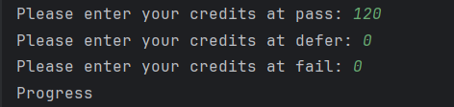

Figure 1 : Progress

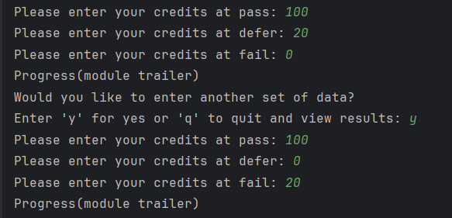

Figure 2:Progress (module trailer)

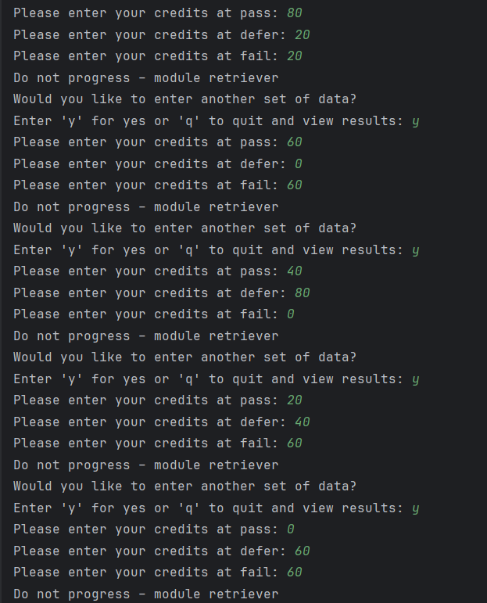

Figure 3:Module retriever

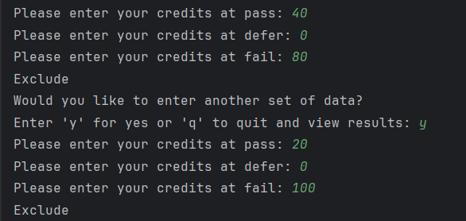

Figure 4:Exclude



Figure 5:Validation 5.1



Figure 6:Validation 5.2

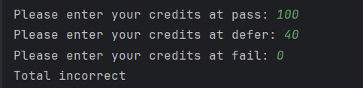

Figure 7:Validation 5.3

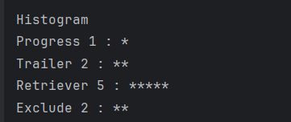

Figure 8: Histogram 7.1



Figure 9: Histogram 7.2

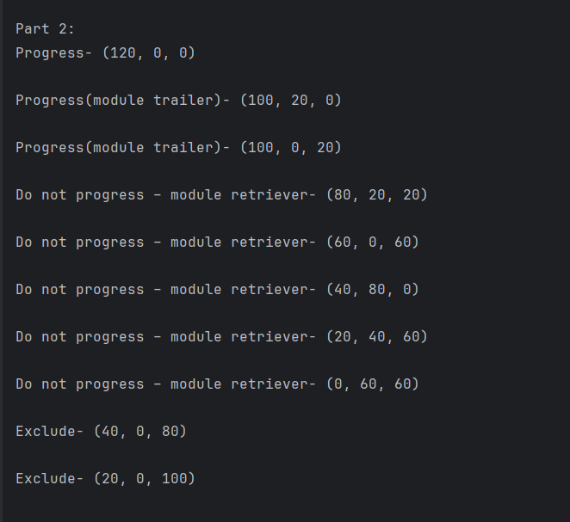

***Figure 10: Part 2***

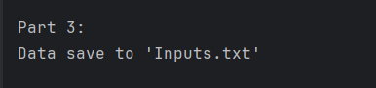

***Figure 11: Part 3***